Chapter 7

Process Design

**Background**

Figure 7.1 represents a modification of the product-process matrix, championed by Hayes and Wheelwright. The new entry in recent years was not thought possible in the past, that is, *mass customization*. We should see more movement towards mass customization in the coming years, copying firms that have successfully implemented this approach.

This chapter is mostly conceptual, incorporating discussion of the four basic process strategies, the primary tools of process design, service process design issues, along with several different examples of technology. Sustainability issues have been increasing in importance in the past few years and are highlighted in this chapter. The chapter lends itself to creativity in the classroom. Students can brainstorm or work on exercises involving things like: (1) potential design of processes for products or services that have not even been invented yet, (2) redesign of processes that students think work poorly now, or (3) applying process analysis and design tools to any process that the instructor deems worthy.

**Class Discussion Ideas**

1. Have the students describe examples of organizations that are using each of the strategies for improving service productivity. They should be able to explain why this approach is expected to lead to a competitive advantage in the marketplace.

2. The instructor can describe a potential new product that has not been invented yet. Then students can be asked how they would produce this product. Various dimensions of process design could be explored, including the degree of capital intensity (manual vs. automated), desired resource flexibility (workforce and machines), degree of vertical integration, and degree of consumer involvement in the process (self-service or customization). Many other dimensions could be discussed as well.

**Active Classroom Learning Exercises**

1. Students can generally grasp the basic concepts of repetitive process through their familiarity with the assembly line concept. Choose a repetitive process they will relate to and briefly discuss its operating characteristics. Then split the students into small groups and, for each group, make a different change to one of the basic elements like variability of demand, product customization, volumes, run lengths, or the like. Have the groups explore why other process choices become advantageous and then report their findings to the rest of the class.

2. Most students will have worked in some sort of service business by the time they read this text. Split the class into small groups. Have each group choose one of the service businesses that a member has worked in. Then have each group create a service blueprint for that operation, not forgetting to identify points of potential failure. Each group can present its findings to the class. An extended exercise would ask each group (or the class as a whole) for ways to minimize the probabilities of failure. Examples might include training, dummy-proofing, inspecting, double-checking, changing the process, etc.

3. Split the class into small groups. Ask each group to develop ideas to improve the sustainability at hotels. Examples might include the Ritz-Carlton doing laundry at night when electricity is cheaper, or the Park Plaza eliminating shampoo bottles and replacing them with built-in dispensers in the shower areas. Many hotels also encourage guests to re-use towels and/or sheets when they are not too dirty. Everyone has stayed in a hotel, so hopefully this exercise can produce some creative ideas. Have each group share its findings with the class.

**Company Videos**

1. *Green Manufacturing and Sustainability at Frito-Lay (6:44)*

Frito-Lay has a top-level commitment to “being green,” including conserving energy, minimizing waste, and saving water. It has a long-term goal of *zero environmental impact*, including a goal of “zero landfill waste,” defined as less than 1% of facility waste going to landfill. Three examples of environmental tactics are described in the video: (1) the 2.2 million pounds of starch produced annually at the Orlando plant through potato washing is treated and sold for other uses; (2) cardboard boxes are reused, saving 5 million trees annually, and (3) the Modesto, California, plant runs on solar power. Frito-Lay forms resource conservation teams to help support its sustainability goals. They are designed to look, listen, and monitor usage of energy and utilities. The firm has received several awards and recognitions for its sustainability initiatives, including from Leadership in Energy & Environmental Design (LEED) and the Environmental Protection Agency (EPA). Frito-Lay is truly a national leader in sustainability.

Prior to showing the video, the instructor might ask the students to guess what percent of waste at the Frito-Lay plant in Orlando goes into landfill. Afterwards, they may be quite surprised to learn that it is only 6.5 % and on the way towards 1%. Further discussion could discuss the pros and cons of manufacturing firms making a concerted effort to become sustainable producers. While some initiatives make money (through, for example, selling waste as inputs to other processes), other initiatives certainly may involve a significant investment. While everyone is in favor of environmental friendliness, at what cost should firms pursue this? Can only large market-dominating companies such as Frito-Lay afford to go green? In the long run, can any firms afford not to? How much do consumers care? Does watching this video make anyone in the class more likely to buy a snack from Frito-Lay than from another manufacturer? Can students share any sustainability initiatives that they have witnessed at companies for which they have worked?

2. *Process Analysis at Arnold Palmer Hospital (7:08)*

Arnold Palmer Hospital uses flow charts for dozens of its operations, including vacated room turnaround time, admissions, inventory, and food service delivery. The bulk of the video describes and shows the process following maternity patients and their paperwork. A series of if-then scenarios determine the steps in the patient experience. Different scenes from these various steps are shown along with the descriptions. The hospital uses a series of bar codes and wristbands to ensure accuracy throughout the patients’ stay. The hospital’s commitment to continuous improvement is emphasized.

Prior to showing the video, instructors might ask the students to jot down as much of the maternity patient process flow as they can pick up with one viewing of the video. Perhaps small groups could then be formed to try to draw the appropriate flow chart. For discussion, students might be asked about the pre-registering function. What do they think might be involved in pre-registration? How does pre-registration streamline operations? Why is it particularly useful for expectant mothers?

3. *Process Strategy at Wheeled Coach Ambulance (6:50)*

The primary point of this video is that Wheeled Coach utilizes a repetitive process supported by work cells when producing its custom-build ambulances. Thus, the firm uses a hybrid approach of an assembly line supported by customization. The less skilled workers work on the assembly line, while the more skilled workers are in the work cells. The key work cells at Wheeled Coach include: upholstery, electrical wiring, cabinetry, and aluminum fabrication. The video examines the electrical wiring work cell in particular. Each vehicle has an astounding 15 miles of electrical wiring, similar to an F-16 fighter jet. This wiring is delivered to the assembly line just-in-time to be put into the proper vehicle for which it was produced. The Plant Manager also emphasizes the usefulness of the CAD (computer-aided design) system, noting that it helps not only with design, but also with sales and manufacturing. Customer demand for ambulances continues to become more taxing, as users wish these vehicles to become almost mini-hospitals inside. Wheeled Coach’s work cells allow the flexibility for such customization, while the assembly line piece of the process keeps churning out the vehicles at a reasonable pace.

Prior to showing the video, instructors might ask the students to think about different industries that require customized products and how the processes might be designed to allow for such customization. Afterwards, students could be asked to compare and contrast a process such as the one utilized by Wheeled Coach with some of the others that they identified (perhaps flexible manufacturing systems and machines, or perhaps hand-made items or even service processes that have customers perform some of the customization themselves).

**Cinematic Ticklers**

1. *Modern Times*, *(Charlie Chaplin), CBS/FOX VIDEO, 1992 (1936)*

Also suggested as a possibility for Chapter 1, the movie deals with worker alienation in an assembly line environment and offers an interesting historical perspective on early Taylorism. Interesting issues arise, including workers having to clock out to go to the bathroom, the automatic assembly line being sped up as the day wears on, sneezing or scratching being enough to make one behind on his or her work, and, most importantly, the de-humanization of early assembly line work.

2. Pretty much any of the 190 *Three Stooges* (Columbia Pictures) shorts starts with the Stooges working on a job that is either poorly designed or that they cannot operate efficiently.

**Presentation Slides**

INTRODUCTION (7-1 through 7-11)

Slides 10-11: These two slides feature Harley Davidson, which remains one of the very few U.S. motorcycle manufacturers. The firm owes much of its success to its loyal customer base, but also to a lean production system. Parts that feed the main assembly line are manufactured in work cells (process focus). The assembly line is a repetitive process, but actually contains features of mass customization because Harley can produce a wide variety of products at a rate of up to 600 units per day.



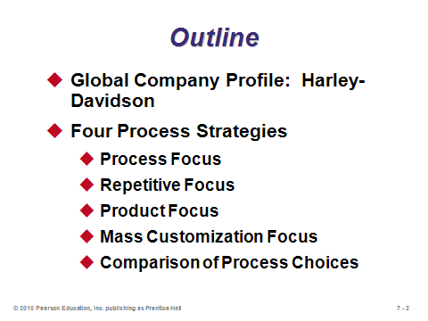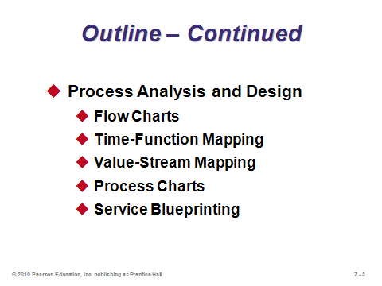

**7-1 7-2 7-3**

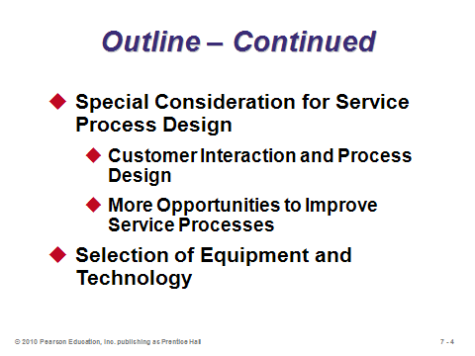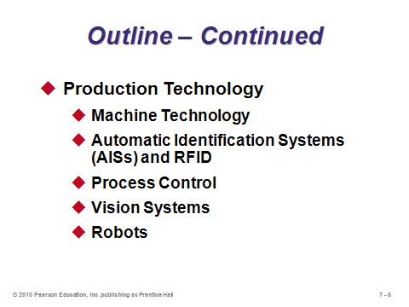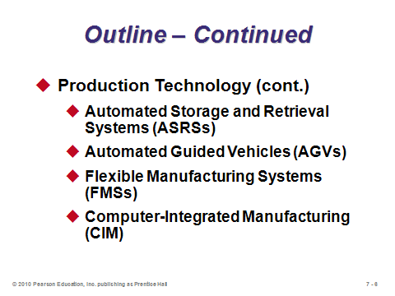

**7-4 7-5 7-6**

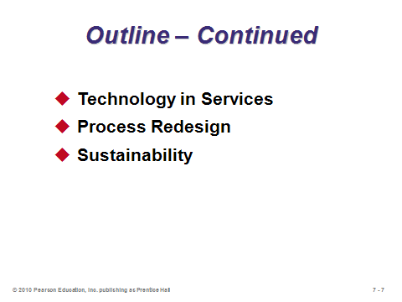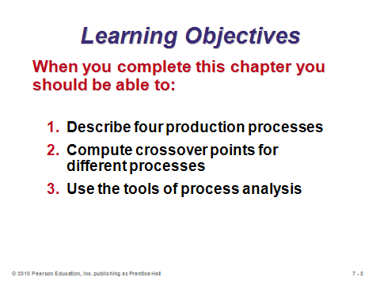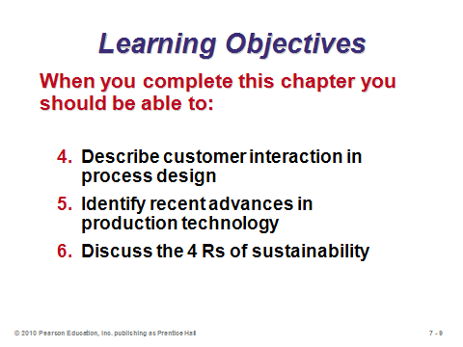

**7-7 7-8 7-9**

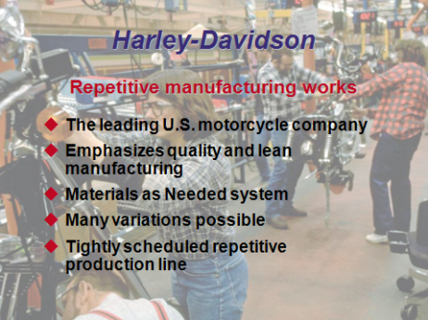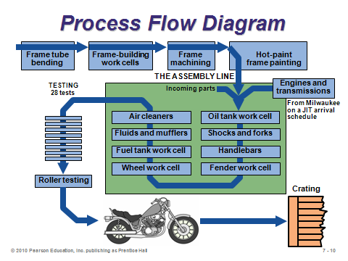

**7-10 7-11**

FOUR PROCESS STRATEGIES (7-12 through 7-35)

Slides 13-15: These slides identify the four basic strategies. Slide 13 reproduces Figure 7.1 from the text, showing where the four main process strategies fit along the matrix of product volume/product variety. Mass customization used to be thought of as unattainable, but technology and reduced changeover costs have opened the possibility for some firms.

Slides 16-17: These slides describe process focus and illustrate it with Arnold Palmer Hospital. In general, the product or customer going through a process focus facility has no pre-defined flow. Any particular product or service may undertake a unique route through the system. Such systems, like job shops or banks, end up with certain processes having long waiting lines while other processes in the facility may be empty.

Slides 18-19: These slides describe repetitive focus and illustrate it with Harley Davidson. A typical assembly line is a repetitive focus, as is a batch flow system. Repetitive processes have some flexibility in creating output variety but are limited by the variety of subassemblies that reach the assembly line.

Slides 20-22: These slides describe product focus and illustrate it with both Frito-Lay and Nucor Steel. Product focused operations are often called continuous flow systems, and they may run 24 hours per day, not stopping for changeovers for weeks at a time. Product focus is all about creating very high volume in the most efficient way possible.

Slides 23-27: These slides describe mass customization and illustrate it with the Dell Computer model. Slide 24 provides some nice examples of how the number of choices for some products has skyrocketed in the past 30-40 years. Mass customization is designed to fulfill those increasingly varying customer needs while still producing large volumes at a reasonable cost. As Slide 25 suggests, the key to successful implementation of mass customization often rests in designing products and processes that incorporate common subassemblies. In this way, final customized assembly can occur very quickly to create a unique product, yet the firm does not have to produce and hold every product option in inventory. This technique is called *postponement*. Slide 26 shows that mass customization often involves elements of the other three basic process strategies. Slide 27 identifies typical necessary conditions for successful mass customization.

Slides 28-32: These slides replicate Table 7.2 from the text, which arguably contains the most important conceptual information in the chapter. It is probably worth spending several minutes covering those comparisons, point-by-point. Characteristics in the repetitive process column typically represent a compromise or intermediate position between the two extremes of process focus and product focus. To achieve mass customization, the firm would have to ask itself what investments or changes might be required to move from its current strategy in column 1, 2, or 3 to column 4.

Slide 33: Crossover charts represent the only real math in Chapter 7. Slide 33 reproduces Figure 7.4 from the text, which illustrates Example 1. The slide does not discuss the calculations (which are relatively simple), but it does illustrate the concepts. If the fixed and variable costs of different production strategies can be accurately estimated, crossover charts help to determine the ranges of volume for which each strategy is cheapest.

Slide 34: Focusing on processes implies a move toward specialization, limiting the number of activities, products, and/or technologies. “Focus” is often a reason given why firms outsource so many activities. The concept of focused processes sounds like the opposite of the goal of mass customization. In fact, the instructor might want to ask the students why the book seems to be touting the benefits of both. Which is better to strive for? Is it possible to have “focused mass customization?”

Slide 35: This slide emphasizes that process change can be difficult and expensive, impacting many of the 10 OM decisions. The proper process choice up front is crucial.

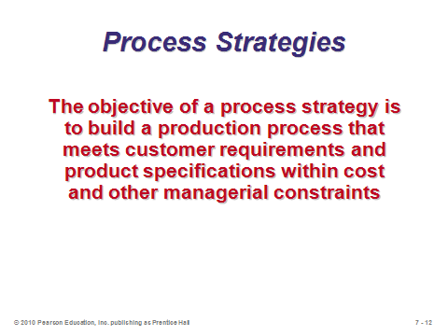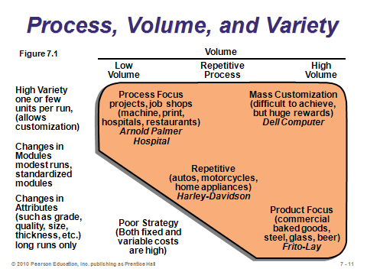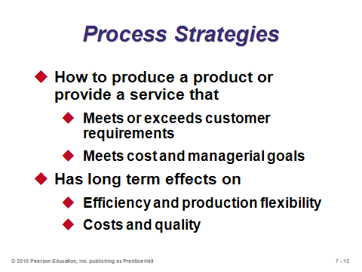

**7-12 7-13 7-14**

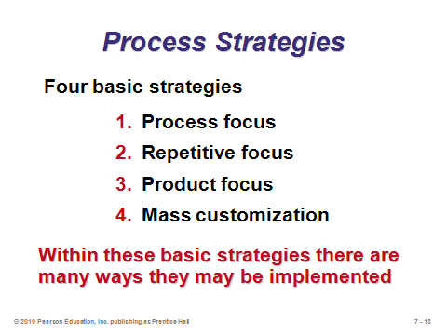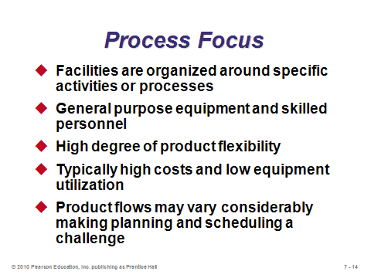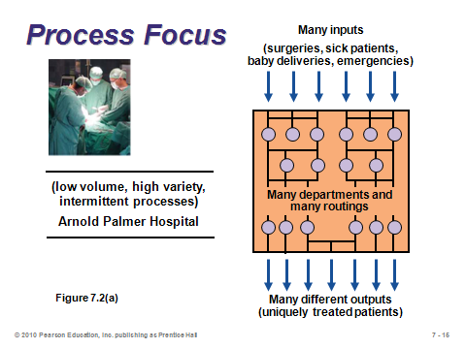

**7-15 7-16 7-17**

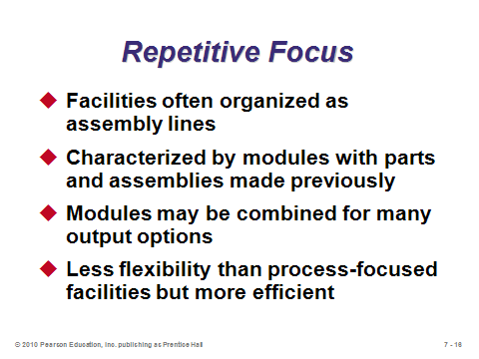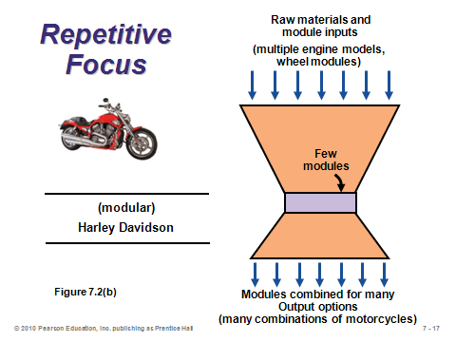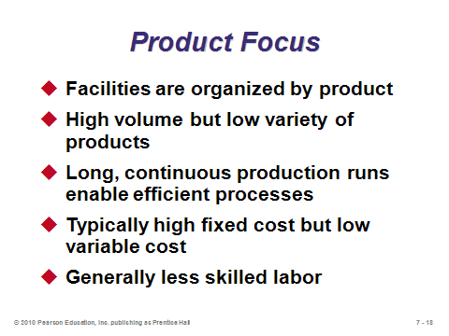

**7-18 7-19 7-20**

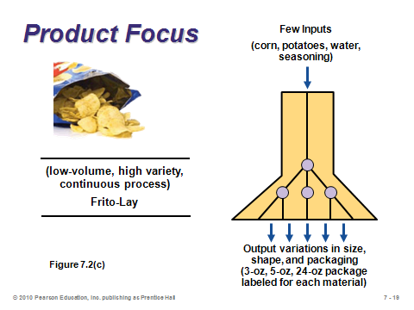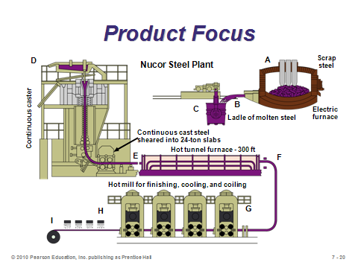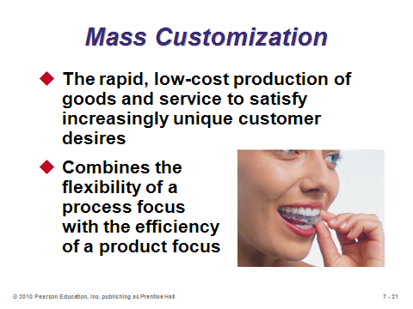

**7-21 7-22 7-23**

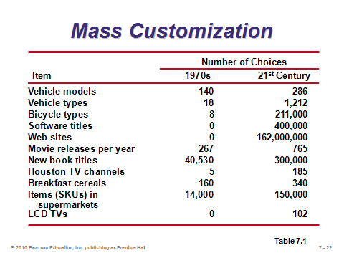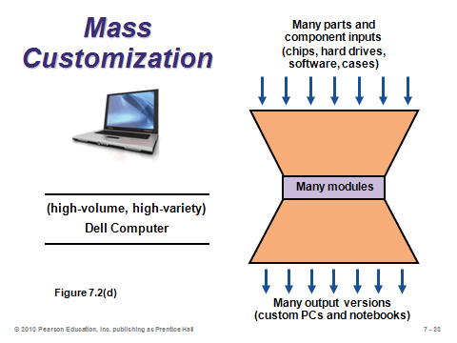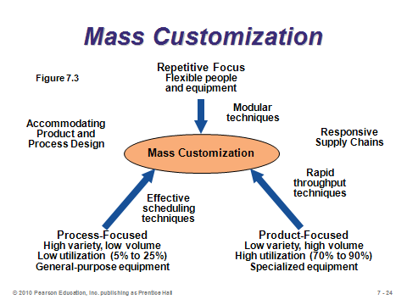

**7-24 7-25 7-26**

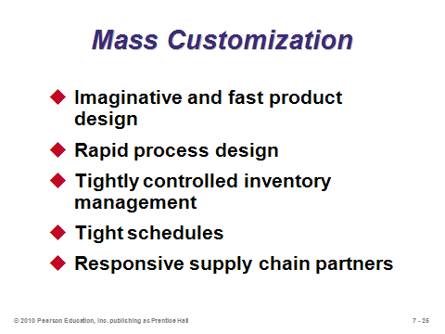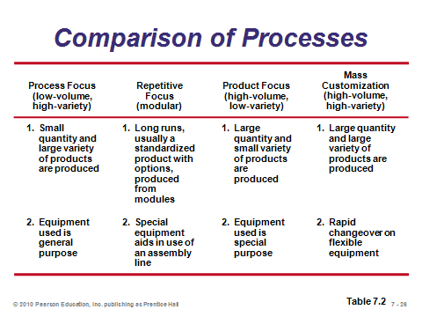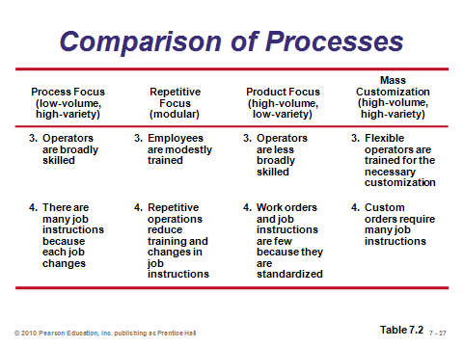

**7-27 7-28 7-29**

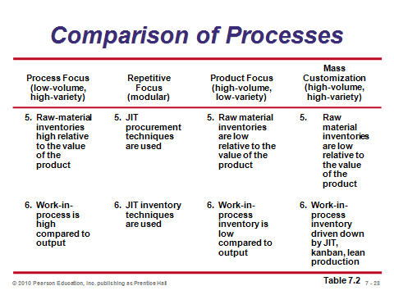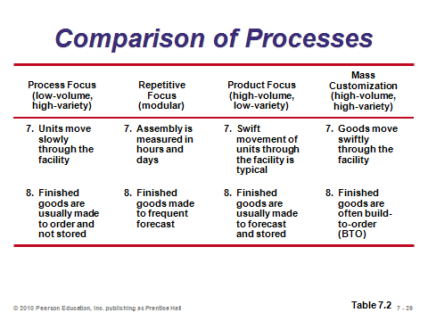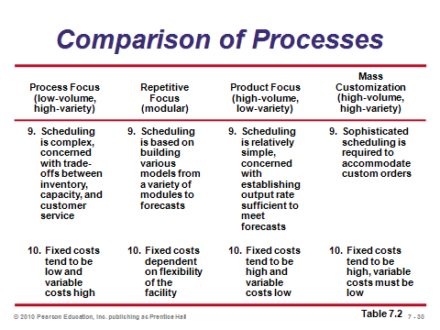

**7-30 7-31 7-32**

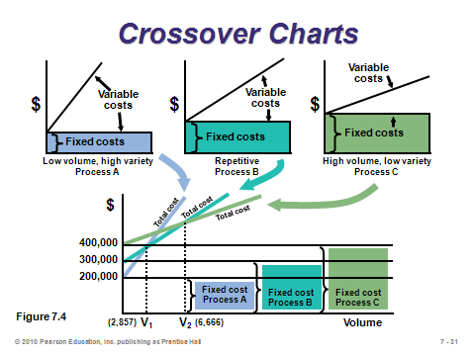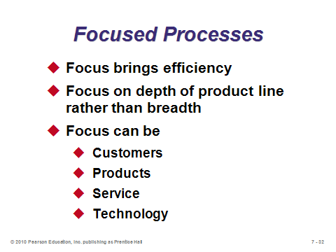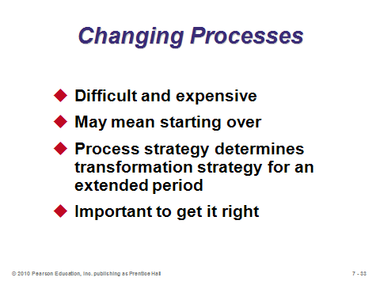

**7-33 7-34 7-35**

PROCESS ANALYSIS AND DESIGN (7-36 through 7-45)

Slide 36: These represent important questions to ask when analyzing and designing a process.

Slides 37-39: Flow charts and time-function mapping are introduced here—the difference in the two being that time-function mapping is a flowchart with time included on the *x*-axis. Drawing a flow chart should be the typical first step in any design or analysis effort. The two charts in Slides 38 and 39 come from Figure 7.5 of the text, illustrating a before and after time-function map used in process improvement at American National Can Company. The firm was able to eliminate the significant waiting that had slowed things down before improvement was implemented.

Slides 40-45: The other three process analysis tools are presented in these slides. Slide 45 provides a summary of the primary benefits of each of the five tools. Slide 41 shows a value-stream map, which can look complicated because the full supply chain is included in the picture. From this example, we see what looks like a significant amount of inventory, as well as a large percentage of non-value added time. As Example 2 in the text suggests, one way to reduce raw materials inventory might be to have deliveries twice per week instead of once per week. A process chart, like the one shown in Slide 42, breaks down steps into detail and can provide a structured way to examine value-added vs. non-value added activities. Slides 43 and 44 illustrate service blueprinting, which is applicable for high service processes. Level 1 activities are under the control of the customer; level 2 activities represent interactions, and level 3 activities include activities not visible to the customer. The identification of potential failure points is particularly useful.

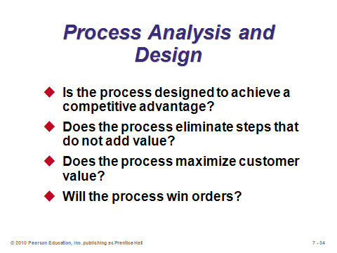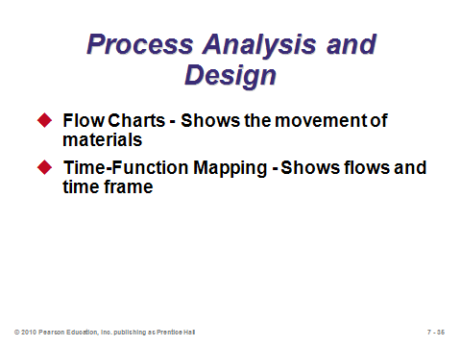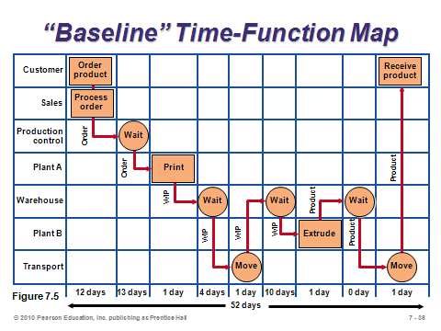

**7-36 7-37 7-38**

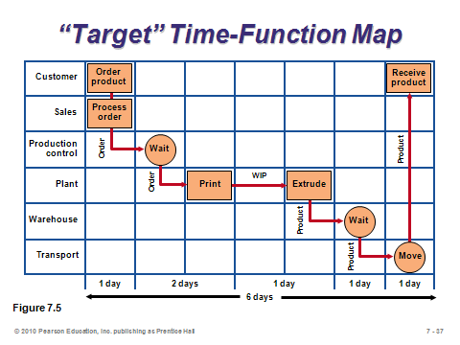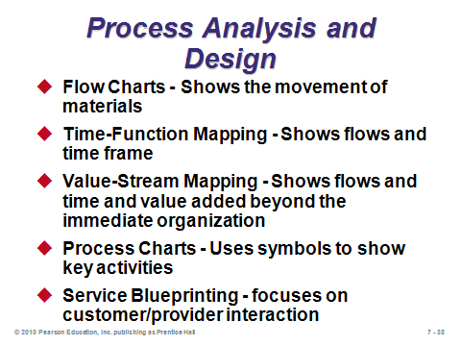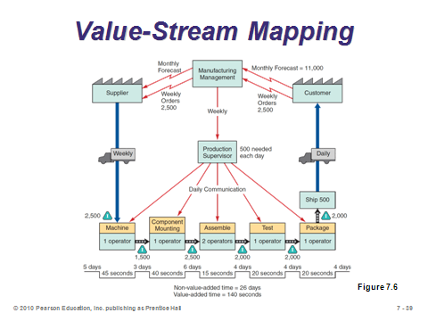

**7-39 7-40 7-41**

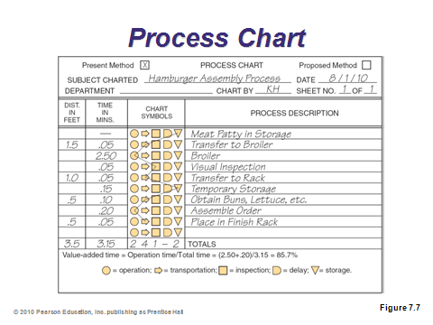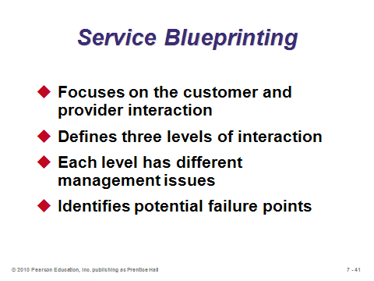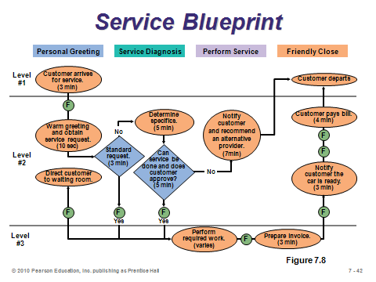

**7-42 7-43 7-44**

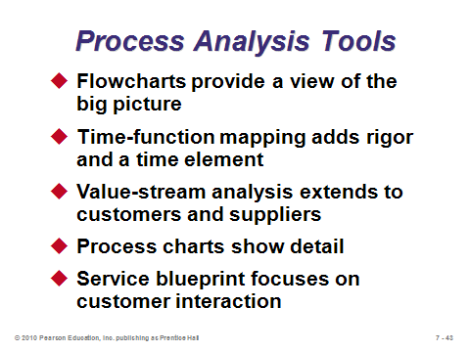

**7-45**

SPECIAL CONSIDERATIONS FOR SERVICE PROCESS DESIGN (7-46 through 7-53)

Slide 46: Customers are usually not involved in manufacturing operations. They often are involved in service operations, however, which is why service design can be particularly tricky.

Slides 47-49: These slides describe the service process matrix, where types of service are split into four quadrants based on degree of customization and degree of labor. The arrows in Slide 47 represent how services in the rectangles can find a competitive opportunity by moving to the ovals.

Slides 50-52: These slides reproduce Table 7.3 from the text, which presents techniques for improving service productivity, including an example of each.

Slide 53: This slide emphasizes the importance of both layout and human resources in service design. The aesthetics of layout are important, but so are aspects of enhancing efficient flow, exposing and enhancing the product, and educating the customer. For human resources, even though some services are among the lower-paying professions, employee skills, particularly interpersonal skills, can be crucial to service firm success. Such employees need to be flexible as well, particularly regarding work scheduling and being able to fill in for other responsibilities when called upon.

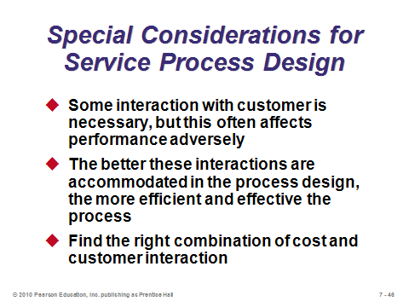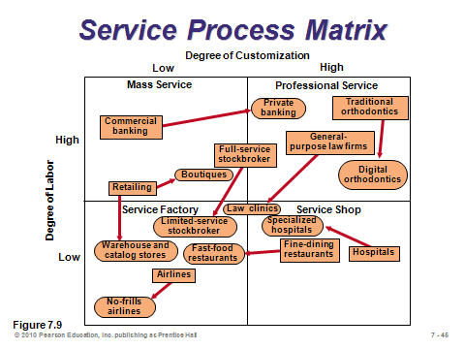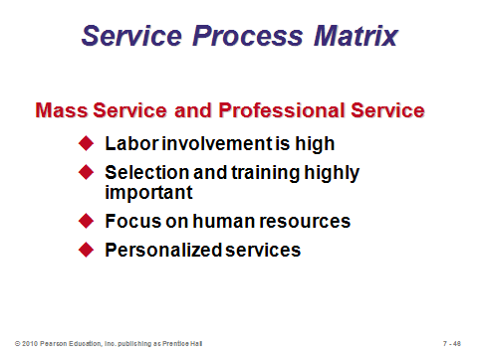

**7-46 7-47 7-48**

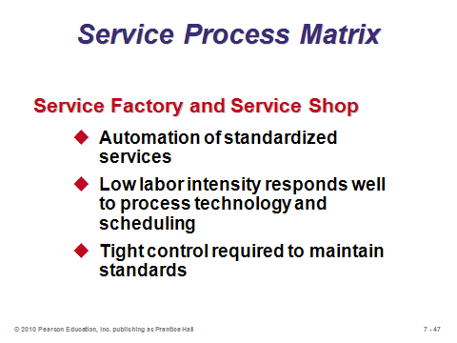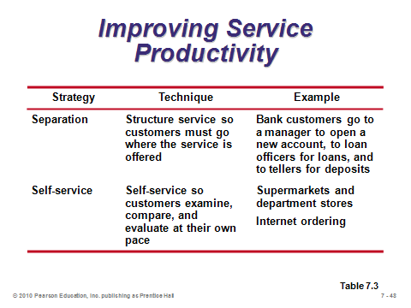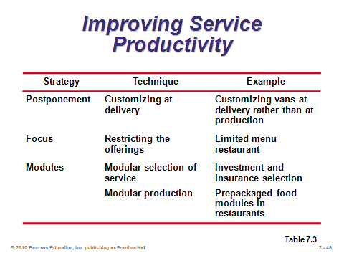

**7-49 7-50 7-51**

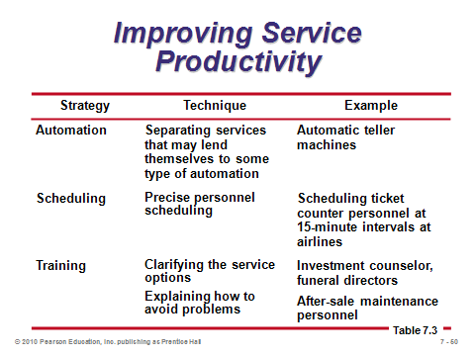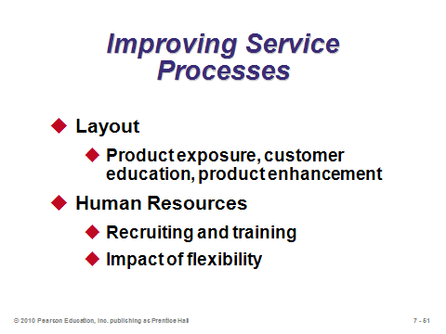

**7-52 7-53**

SELECTION OF EQUIPMENT AND TECHNOLOGY (7-54)

Slide 54: This single slide is from the introductory section on technology. It is important to emphasize that the technology decision is not always obvious, and it may involve a large capital expenditure. Equipment that is more accurate or breaks down less often may lead to more stable processes. Flexible equipment provides the ability to respond to new orders/make different products with little penalty in time, cost, or customer value. Flexible equipment may allow managers to enlarge the scope of their processes.

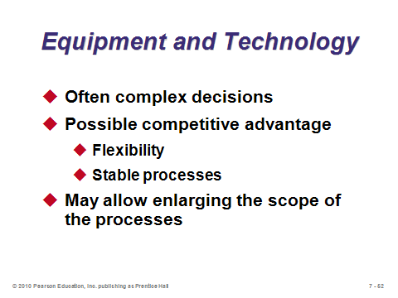

**7-54**

PRODUCTION TECHNOLOGY (7-55 through 7-65)

Slides 55-65: Slide 55 identifies nine types of production technology, which are then described in the next 10 slides. Slide 56 identifies the improvements that modern machine technology has introduced, especially when computer numerical control (CNC) machines are employed. The AIS applications described in Slide 57 refer to things like bar codes and RFID—anything that eliminates manual data entry. Bar codes allow warehouses to automatically sort hundreds of boxes per minute, and they significantly speed up the checkout process at retail stores, even allowing for the self-checkout stations that are becoming more and more prevalent. RFID has unlimited potential. As the picture in Slide 57 implies, RFID may someday allow customers to have all items in their cart totaled in an instant, without any physical handling. It could also act as an effective security devise against shoplifting. Slide 58 describes process control, which *automatically* monitors output, signaling when a discrepancy exists. Vision systems (Slide 59) are similar to process control, but focus, in particular, on replacing human visual inspection with the aid of video cameras and computer technology. We often think of robots (Slide 60) when we think of the modern factory. Many robots have been around for decades, but they have hardly replaced all human manufacturing jobs. They are especially useful to replace monotonous or dangerous tasks. Preventive maintenance is crucial with robots, however, because a broken robot may shut down an entire assembly line, whereas a sick worker might more easily be replaced. Interestingly, ASRSs (Slide 61) have been employed for products as large as automobiles, using cranes that move in three dimensions. An additional advantage of ASRSs is that the warehouse, by not utilizing people, can remain in cold semi-darkness. The army uses AGVs (Slide 62) for particularly dangerous missions such as traversing across a mine field. Flexible manufacturing systems (Slide 63) represent a possible way for firms to achieve mass customization. Computer-integrated manufacturing (Slide 64) extends an FMS backwards (into engineering and inventory control) and forwards (into warehousing and shipping). There is not a single standard CIM application, but the idea is to have computer-aided communication and control to help manage an entire production process. Slide 65 provides a nice example of the possibilities of CIM.

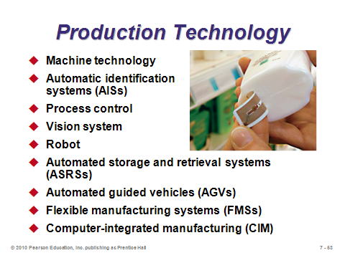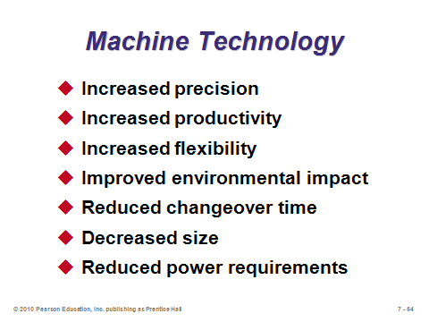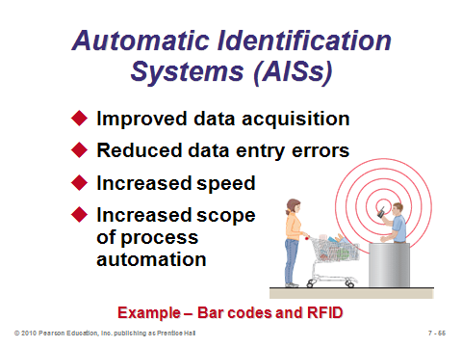

**7-55 7-56 7-57**

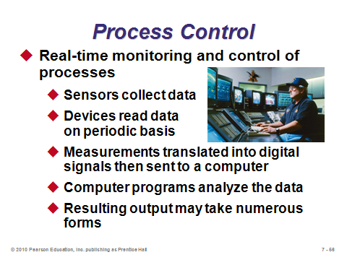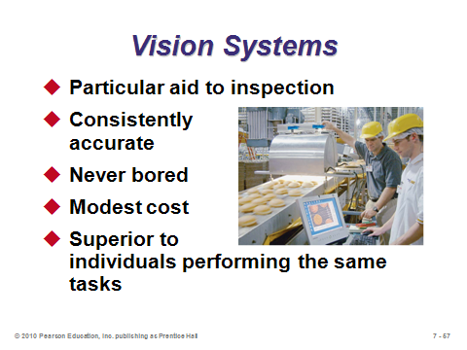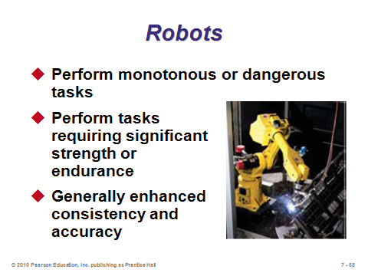

**7-58 7-59 7-60**

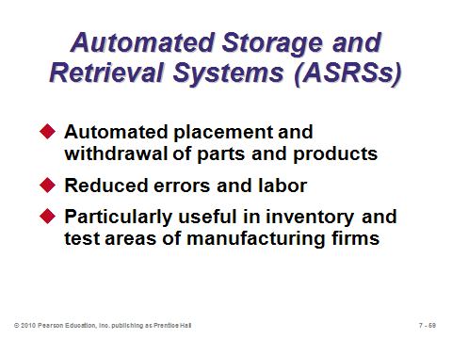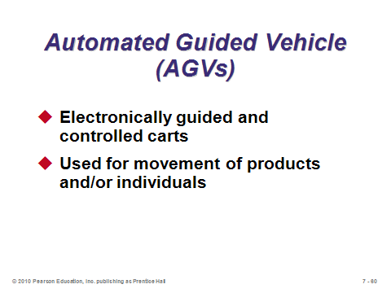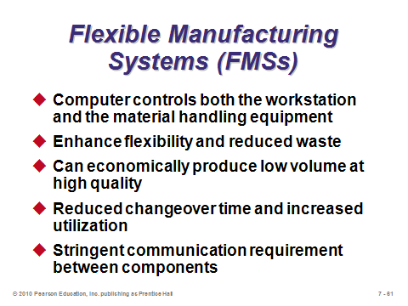

**7-61 7-62 7-63**

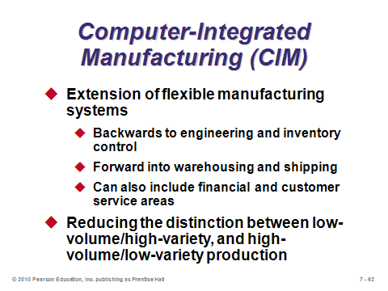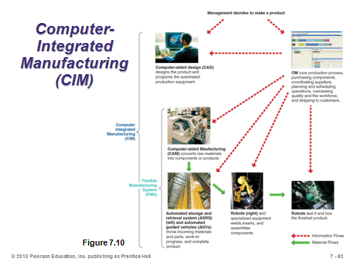

**7-64 7-65**

TECHNOLOGY IN SERVICES (7-66 through 7-67)

Slides 66-67: These slides reproduce Table 7.4 from the text. Here we see several examples of technology literally changing the way that service processes operate and the way in which customers obtain services. In some cases, such as online news outlets vs. physical newspapers, traditional service offerings have become endangered. In other cases, such as the ability to pre-order lunch at the ninth tee box on a golf course, technology may have opened new markets. Instructors can spend a fair amount of time on these two slides, even brainstorming with students about what might be coming next. For example, what else can be crammed into the next smart phone?

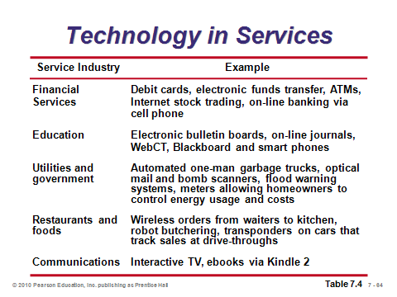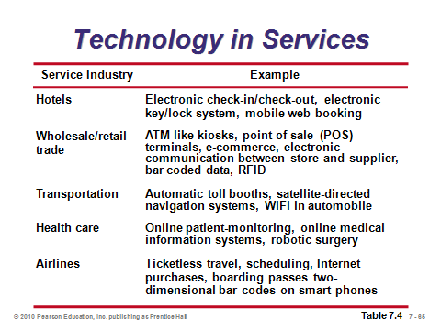

**7-66 7-67**

PROCESS REDESIGN (7-68)

Slide 68: A few years ago, the hot catch phrase for process redesign was “business process reengineering.” Whatever the term, now and then a process should be re-examined to see if it remains the appropriate vehicle for producing the product or providing the service. Such examination may be spurred by new products or product mixes, changes in competitive priorities of the company, changes in volume of demand, poor performance, new technology, changes in the cost or availability of inputs, or perhaps new legislation/regulation. As humans seem to get attached to the familiar, process redesign is often easier said than done. Sometimes a consultant or other objective set of eyes may be needed to break down certain assumptions that are presumed to be untouchable by the current workforce. Nevertheless, as with any organizational change, success usually follows those change efforts that include all employees in the fact-finding and decision-making processes.

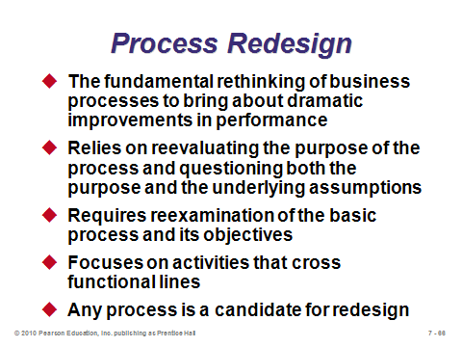

**7-68**

SUSTAINABILITY (7-69 through 7-71)

Slides 69-71: The concept of sustainability is receiving a lot of attention recently, and it shows no sign of slowing. These slides identify aspects of each of the four *R*’s of sustainability: resources, recycling, regulations, and reputation.

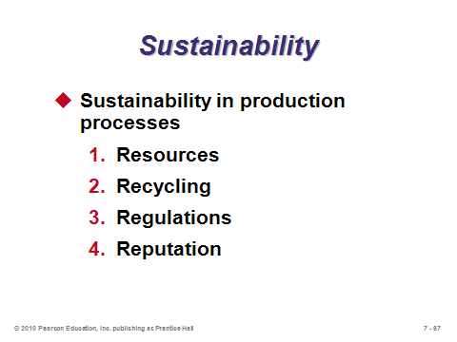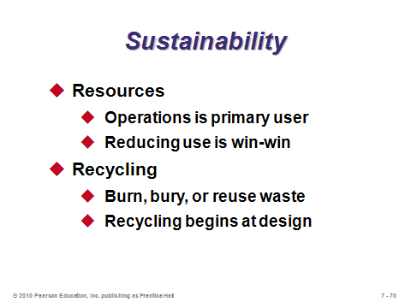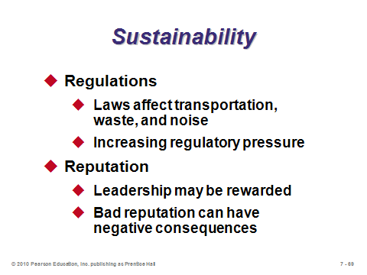

**7-69 7-70 7-71**

**Additional Assignment Ideas**

1. (BPR) Business Process Reengineering Online Learning Center. Here you will find lots of information; check out the tutorial section. Choose one tutorial and form a summary of that tutorial. www.prosci.com/index.htm

2. Visit the carbon footprint website www.carbonfootprint.com/calculator.aspx. Calculate your personal carbon footprint. If you live in a dorm and do not pay energy bills, consider calculating the carbon footprint for a family member. Print out the results page. What is your carbon footprint, and how does it compare to the country average? How much money does the site suggest that you invest in order to offset your footprint?

**Additional Case Studies**

Internet Case Study (www.pearsonglobaleditions.com/heizer)

* *Matthew Yachts, Inc*.: Examines a possible process change as the market for yachts changes.

Harvard Case Studies (http://harvardbusinessonline.hbsp.harvard.edu)

* *Massachusetts General Hospital* (#696-015): Describes efforts at Massachusetts General Hospital to reengineer the service delivery process for heart bypass surgery.
* *John Crane UK Ltd.: the CAD/CAM Link* (#691-021): Describes the improvement of manufacturing performance in a job shop.
* *Product Development at Dell* (#699-010): Discusses the new product and process and the management of development risk.

**Internet Resources**

|  |  |
| --- | --- |
| American Council of Engineering Companies | www.acec.org |
| Association of Automatic Identification and Mobility | www.aimglobal.org |
| Association for Manufacturing Excellence | www.ame.org |
| Business Process Reengineering online learning tutorial | www.prosci.com/index.html |
| DARPA: U.S. Defense Dept., Innovative Prototype Systems | www.DARPA.mil |
| Dassault Systems | www.dsweb.com |
| Graham Process Improvement Methodology | www.worksimp.com |
| iGraphic’s approach to value-stream mapping | www.iGrafx.com |
| Strategos Inc.’s approach to value-stream mapping | www.strategosinc.com |
| Traleon GMBH’s approach to value-stream mapping | www.valuestreamdesigner.com |
| WARIA, the Workflow and Reengineering International Association | www.waria.com |

**Other Supplementary Material**

Video

Film available from:

Society of Manufacturing Engineers

One SME Drive

P.O. Box 930

Dearborn, Michigan 48121-0930

(P) 313-425-3000

(F) 313-425-3412

http://www.sme.org

* *Flexible Manufacturing Cells—*See how Mazak, Badger Meter, and Agnew Machine use FMC's. Order # PI-VT256-3456

Interview with Paul Polman of Unilever—Discussing Unilever’s sustainability efforts.

http://www.mckinseyquarterly.com/Strategy/Strategic_Thinking/McKinsey_conversations_with_global_leaders_Paul_Polman_of_Unilever_2456

* *Business in society: The statue of responsibility*

Hizook: “High-Speed Robot Hand Demonstrates Dexterity and Skillful Manipulation”

http://www.hizook.com/blog/2009/08/03/high-speed-robot-hand-demonstrates-dexterity-and-skillful-manipulation

Computing the Carbon Footprint

To expand on the sustainability discussion, instructors can show a website that calculates the “carbon footprint” for homes or businesses. One such example is www.carbonfootprint.com/calculator.aspx. The home calculator does not require login information and might be more immediately relevant to students. Tabs lead the user through “House,” “Flight,” “Car,” “Motorbike,” “Bus & Rail,” and “Secondary,” with a final “Results” tab that adds it all together and compares to the country average as well as the world target (impossible to attain). The calculations are mostly point-and-click driven. Each subtotal has an “Offset now” button that tells the user what kind of offset in activity and dollars would make up for the carbon footprint imposed on the world by that person. Examples include reforesting in Kenya or funding to support renewable energy. Interested users can donate real money right there through this website. The second “Additional Assignment Idea” below asks students to explore this site.

Equipment Choice with Imperfect Machines

Instructors interested in adding more quantitative material to Chapter 7 could introduce the concept of equipment choice with imperfect machines. Some machines are more accurate than others, but usually are also more expensive. Should the more accurate machine be purchased? Assuming that output is normally distributed with a known mean μ and standard deviation σ, students can calculate the expected yield loss of each machine (note that μ might be able to be set by the user). The probability of output exceed the upper spec limit (USL) = 1 – Φ(*Zup*), where *Zup* = (USL – μ) / σ. The probability of output falling below the lower spec limit (LSL) = Φ(*Zdown*), where *Zdown* = (LSL – μ) / σ (a negative value). Each probability can be multiplied by its cost of fixing output that is too high or too low. (These costs may be different. For example, fixing a wooden board that has been cut too long involves re-cutting the board, but one that has been cut too short might have to be completely scrapped.) For each machine, the expected cost per unit of fixing out-of-spec output can be multiplied by total volume produced to compute total fixing costs. The fixing cost differences can then be compared to the investment cost differences of the two machines.